Subject Area |  | Learning Focus | Useful links (All links are external so please check them carefully before sharing with children )
Writing  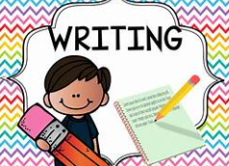 |  | WRITING TO INFORM: This half-term, we’ll be revisiting writing instructions; this time, to detail how best to safely cross the road.  WRITING TO ENTERTAIN: We’ll be revisiting ‘how to write a character description’. We’ve had lots of practise already so we’ll definitely ‘shine’! | https://www.onceuponapicture.co.uk/
Reading  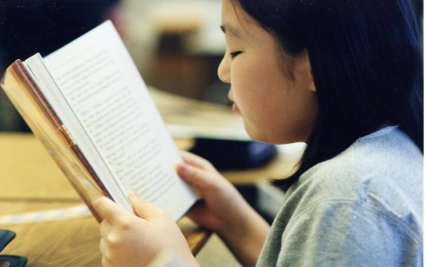 |  | PHONICS: This half-term, we’ll be continuing with Little Wandle’s NEW Year 2 Spelling scheme of learning!  PROSODY: We’ll be practising and improving our fluency and expression when reading aloud.  VIPERS: We’ll be exploring and learning key comprehension skills via a variety of texts.  COMPREHENSION: We’ll be exploring a range of texts and applying our rapidly-developing comprehension skills to better understand them.  MODELLED READERS: ‘The Hodgeheg’ by Dick King-Smith and ‘The Owl who was afraid of The Dark’ by Jill Tomlinson. | https://www.storyberries.com/bedtime-stories-the-easter-bunny-school-easter-stories-for-kids/
Maths  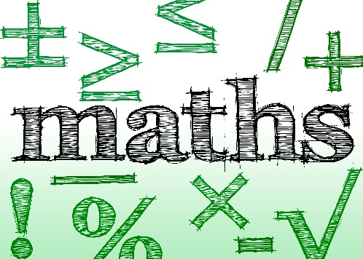 |  | STATISTICS: We’ll be using tally charts to record information and learning how to transfer data to a bar graph before interpreting ‘trends’.  TIME: We’ll be revisiting how to tell the time to ‘o’clock’ and ‘half past’ and learning how to tell the time to ‘quarter to’ / ‘quarter past’. We’ll also be applying our 5 X tables knowledge to learn about ‘5 past’, ’10 past’, etc.  FRACTIONS: We’ll be learning about halves, quarters and thirds of both shapes and quantities. (Our multiplication and division knowledge will really help us to understand this!)  MEASURE: We’ll be using rulers to measure length, height and width and transferring this skill to measure weight, capacity and temperature.  TIMES TABLES: We’ll be practising our 10 X, 2 X and 5 X tables to help us remember multiplication and division facts. | https://mathsframe.co.uk/en/resources/resource/477/Multiplication-Tables-Check  https://www.timestables.co.uk/  https://firstlook.educationcity.com/content/Activity/index/25812
Science   |  | LIVING THINGS & THEIR HABITATS: This half-term we’ll be continuing to investigate the requirements and suitability of habitats for a variety of living things. We will visit Bill’s Wood, our on-site Forest School area and our school pond to further enhance and support our learning. | https://www.stem.org.uk/resources/community/collection/12723/year-2-living-things-and-their-habitats
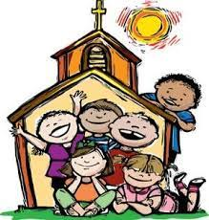  RE |  | LENT: We will be learning about the meaning of Lent: its liturgical colour / its requirements: prayer, almsgiving and fasting / and about Jesus’ time spent in the desert.  HOLY WEEK: Unfortunately, as we won’t be at school during Holy Week, this will be explored during its previous week. We will learn about Palm Sunday, The Last Supper, The Stations of The Cross, Good Friday and… (we’ll save the miracle of Jesus’ resurrection until we return to school following The Easter break) Shh…
History  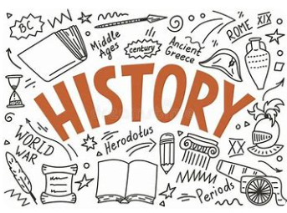 |  | WHY PEOPLE MAKE JOURNEYS: This half-term we’ll be completing our learning about ‘The Titanic’ before moving on to ‘The History of Flight’. We’ll be learning about the innovative invention of Wilbur and Orville Wright before exploring the adventures of Amelia Earhart. We’ll continue to track the progress of flight, as a means of travel, up to its current day. | https://www.bbc.co.uk/bitesize/articles/zdcskmn
Music   |  | SINGING: This half-term, our learning theme will be ‘Toys’. We will be learning about ‘dynamics’, ‘tempo’, ‘pitch’ and ‘timbre’ and how to locate, follow and create musical patterns. | https://www.daspmusic.co.uk/ks2-10-15-min-sings.html
ART/D&T  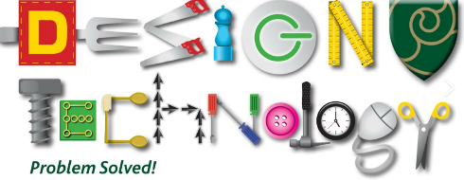   |  | D&T – CREATING A HEALTHY WRAP: In this unit children will draw upon their prior knowledge of food groups / a balanced diet to consider the process involved in designing a healthy food wrap. They will test ‘taste combinations’ before designing and creating their wrap.
PE / Games  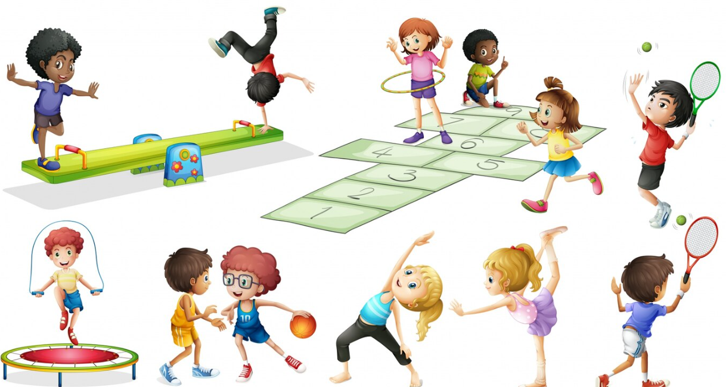 |  | PE: YOGA: We will be learning to copy and repeat yoga poses, develop an awareness of strength and flexibility and to create a ‘yoga flow’.  GAMES: STRIKING & FIELDING: We will be learning how to catch a ball (fielding) and how to roll / throw / hit a ball (striking). We will apply this knowledge to the rules of a game.

