Subject Area |  | Learning Focus | Useful links (All links are external so please check them carefully before sharing with children )
Writing   |  | WRITING TO RECOUNT EVENTS: Writing a diary entry in the voice of April – the main character in The Last Bear.  WRITING TO PERSUADE: Write a persuasive leaflet about visiting Birmingham.  WRITING TO NARRATE: Write an adventure story, creating a new adventure for Lila on her quest. Based on the book The Firework maker’s daughter.  WRITING TO PREFORM - PLAYSCRIPT: Write a playscript for a section of the story, The firework maker’s daughter. | https://www.onceuponapicture.co.uk/
Reading  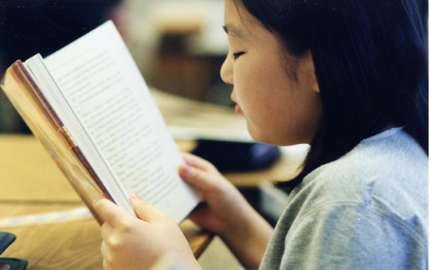 |  | PROSODY: Improving fluency and expression when reading aloud.  VIPERS: Learning key comprehension skills through a variety of texts.  MODELLED READER:  The Last Bear – Hannah Gold  The Cities Book – Lonely Planet Kids  The Firework Makers Daughter – Philip Pullman | https://www.storyberries.com/bedtime-stories-the-easter-bunny-school-easter-stories-for-kids/
Maths   |  | MULTIPLICATION AND DIVISION: Mental and written methods for multiplication and division.  FRACTIONS: recognising fractions, writing fractions and finding a fraction of an amount.  GEOMETRY: Compare and classify geometrical shapes, recognising lines of symmetry in 2D shapes and identifying angles.  TIMES TABLES: Increasing fluency and recall for multiplication and division facts. | https://mathsframe.co.uk/en/resources/resource/477/Multiplication-Tables-Check  https://www.timestables.co.uk/
Science   |  | SOUND: How sounds are heard, how sound travels through different mediums by vibrations, the structure of the inner ear, how to change pitch and loudness of sounds. | Year 4: Sound | STEM
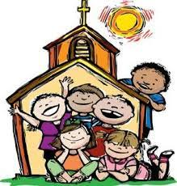  RE |  | JESUS THE LIGHT OF THE WORLD:  Know and understand the story Jesus’ Presentation at the Temple and The Transfiguration. Explore the importance of Baptism and the symbolic use of items.  MULTI-FAITH WEEK: Focus on Hinduism. We will explore what it is that Hindus believe, what they worship and where they pray. This unit will include a visit to Shri Venkateswara Balaji Temple (details to follow).  LENT: Explore the practices during Lent of prayer, fasting, almsgiving and forgiveness.  HOLY WEEK: This unit provides the children with an opportunity to develop their knowledge and understanding of the story of Christ’s passion and death. | https://cafod.org.uk/education/for-families  https://www.loyolapress.com  What is Hinduism? - BBC Bitesize
History  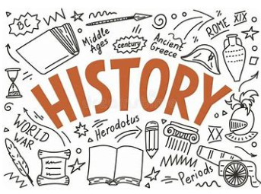 |  | WHY PEOPLE MAKE JOURNEYS: Our focus is on why people make journeys to invade or attack. We will look at the Roman Empire, Anglo Saxons and WW2. | BBC - Search results for roman empire  BBC - Search results for anglo saxons invade
Music   |  | BRASS: Children will continue to learn to play their brass instruments this term.  SINGING: Weekly choir sessions with Mr Wong from Archdiocese of Birmingham Schools Singing Programme.  We will also continue to develop our singing skills through hymn practice with Mrs Vinti. | https://www.daspmusic.co.uk/ks2-10-15-min-sings.html
ART/D&T     |  | FABRIC OF NATURE: Children will take inspiration from the rainforest to create drawings from selected images using chalks and pastels. Creating mood boards inspired by their drawings. Explore and understand the work of artists inspired by the world around us.  D&T – ADAPTING A RECIPE: In this unit children will consider the process involved in designing a biscuit. Starting from taste testing existing biscuits, making comparisons, making biscuits, evaluating their bake, considering how to budget and finally designing a biscuit and packaging.

