Subject Area |  | Learning Focus | Useful links (All links are external so please check them carefully before sharing with children )
Writing  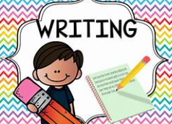 |  | WRITING to present arguments: Writing a balanced argument about banning mobile phones.  WRITING to describe:  Detailed description of Grendel/ Beowulf.  WRITING to Narrate: sequel adventure story of Beowulf and the death of the dragon deep. | https://www.onceuponapicture.co.uk/
Reading  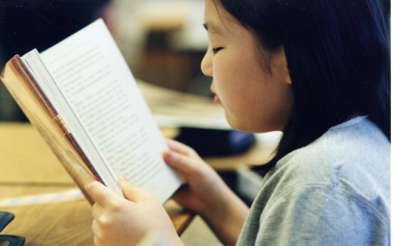 |  | PROSODY: Improving fluency and expression when reading aloud.  VIPERS: Learning key comprehension skills through a variety of texts.  MODELLED READER:  Floodland by Marcus Sedgwick.  The Geat by John Harris. | https://www.storyberries.com/bedtime-stories-the-easter-bunny-school-easter-stories-for-kids/
Maths  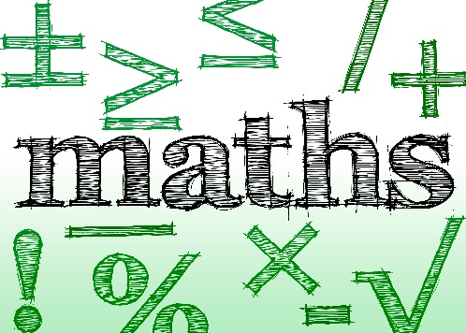 |  | Place value:  Negative numbers and roman numerals.  Geometry and Shape:  Properties of shape, positioning and direction. | https://mathsframe.co.uk/en/resources/resource/477/Multiplication-Tables-Check  https://www.timestables.co.uk/
Science  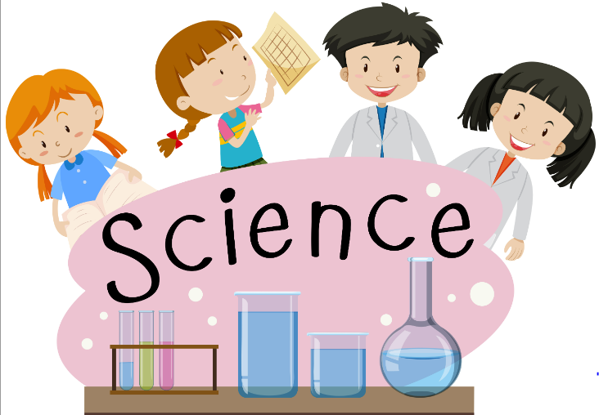 |  | Materials:  Mixtures and reactions.  Animals and Humans:  The lifecycles of humans and animals. | https://www.stem.org.uk/resources/community/collection/12347/year-5-earth-and-space
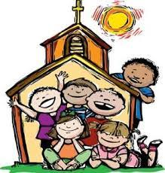  RE |  | Easter:  Focusing on the period of Easter.  Celebrating the time of Jesus resurrection.  MULTI-FAITH WEEK: Focus on Sikhism. We will explore what it is that Sikh’s believe, what they worship and where they pray. This unit will include a visit to the Gurdwara (details to follow).  Pentecost:  Learning about the season of Pentecost. | https://cafod.org.uk/education/for-families  https://www.loyolapress.com  https://www.bbc.co.uk/bitesize/articles/zkjpkmn
Geography |  | Coasts:  Learning about coasts in the United Kingdom. | https://www.bbc.co.uk/bitesize/topics/z87tn39
Music  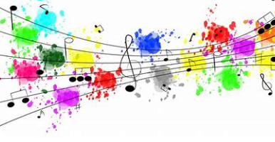 |  | Rock and roll:  Learning to be part of an ensemble for rock and roll music. | https://www.bbc.co.uk/programmes/articles/3g0Lvw1cYkd7fT5qvJ4r5wV/ukulele
ART/D&T  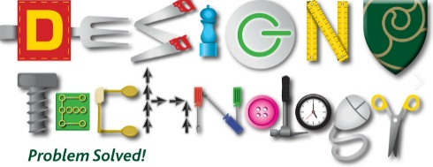   |  | Art and design skills:  Drawing and creating mixed media art work.  D&T:  Cooking and nutrition and textiles.

