Subject Area |  | Learning Focus | Useful links (All links are external so please check them carefully before sharing with children )
Writing  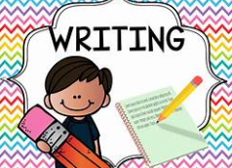 |  | WRITING TO PERFORM: Writing a playscript based on the poem ‘The Highwayman’.  Looking at the arrival of the Highwayman, at the Inn.  WRITING TO RECCOUNT:  Writing a diary entry in the role of Tim the Ostler.  WRITING TO PERSUADE: Writing a persuasive speech to convince Kester to help find the cure in role as the stag. | https://www.onceuponapicture.co.uk/
Reading  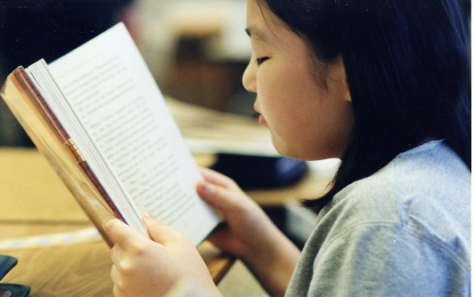 |  | PROSODY: Improving fluency and expression when reading aloud.  VIPERS: Learning key comprehension skills through a variety of texts.  MODELLED READER:  Street Child by Berlie Doherty.  The Last Wild by Piers Torday. | https://www.storyberries.com/bedtime-stories-the-easter-bunny-school-easter-stories-for-kids/
Maths  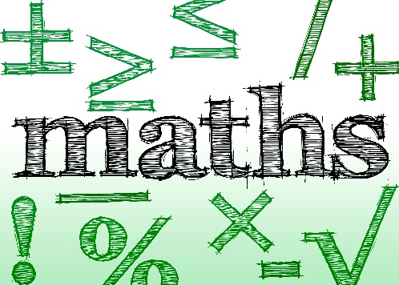 |  | FRACTIONS: Finding a fraction of an amount, fractions and the four operations, Improper fractions and mixed numbers,  FRACTIONS, DECIAMLS AND PERCENTAGES:  Finding equivalence and working with fractions, decimals and percentages.  TIMES TABLES: Increasing fluency and recall for multiplication and division facts. | https://mathsframe.co.uk/en/resources/resource/477/Multiplication-Tables-Check  https://www.timestables.co.uk/
Science  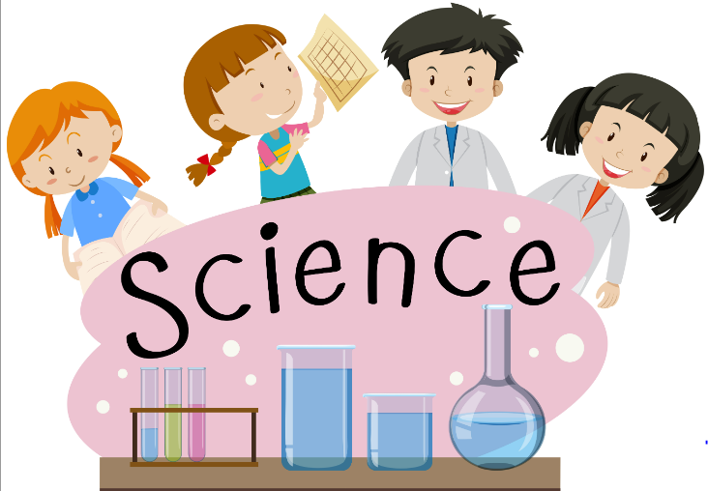 |  | EARTH AND SPACE:  Looking at the makeup of planets in our solar system, night and day, the moon and moon phases and the Earth, sun and moon. | https://www.stem.org.uk/resources/community/collection/12347/year-5-earth-and-space
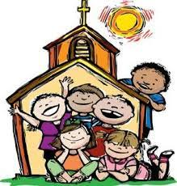  RE |  | BAPTISM:  Focussing on the baptism of Jesus.  Looking at john the Baptist.  Baptism as a holy sacrament.  MULTI-FAITH WEEK: Focus on Sikhism. We will explore what it is that Sikh’s believe, what they worship and where they pray. This unit will include a visit to the Gurdwara (details to follow).  LENT:  HOLY WEEK: | https://cafod.org.uk/education/for-families  https://www.loyolapress.com  https://www.bbc.co.uk/bitesize/articles/zkjpkmn
History  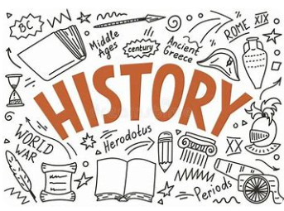 |  | WHY PEOPLE MAKE JOURNEYS: Our focus is on why people make journeys to / for trade. We will look at the Ancient Greeks, the silk road and the slave trade. | https://www.bbc.co.uk/bitesize/topics/z87tn39
Music  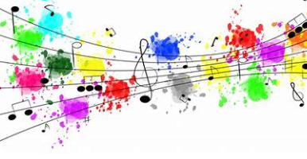 |  | UKULELE: Children have ten sessions over the term, learning to play the ukulele. | https://www.bbc.co.uk/programmes/articles/3g0Lvw1cYkd7fT5qvJ4r5wV/ukulele
ART/D&T  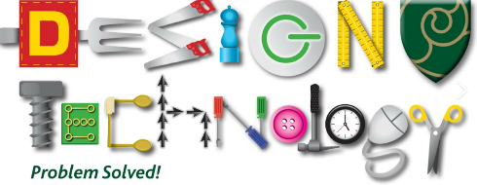   |  | PORTRAITS:  Children to develop a portrait drawing using different materials.  Focussing on different features of the face to make our drawings unique.  D&T – SPAGHETTI BRIDGES:  Explore structures using spaghetti.  Making sturdy structures and testing them.

